**Lab Exercise 4- Working with Docker Networking**

Jahnavi Anand | B1

500106908 | R2142220089

**Step 1: Understanding Docker Default Networks**

Docker provides three default networks:

* bridge: The default network when a container starts.
* host: Bypasses Docker’s network isolation and attaches the container directly to the host network.
* none: No networking is available for the container.

**1.1. Inspect Default Networks**

Check Docker's default networks using:

docker network ls

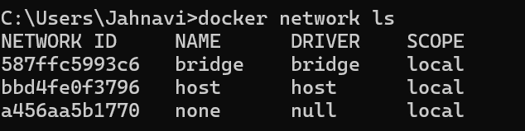

**1.2. Inspect the Bridge Network**

docker network inspect bridge

This command will show detailed information about the bridge network, including the connected containers and IP address ranges.

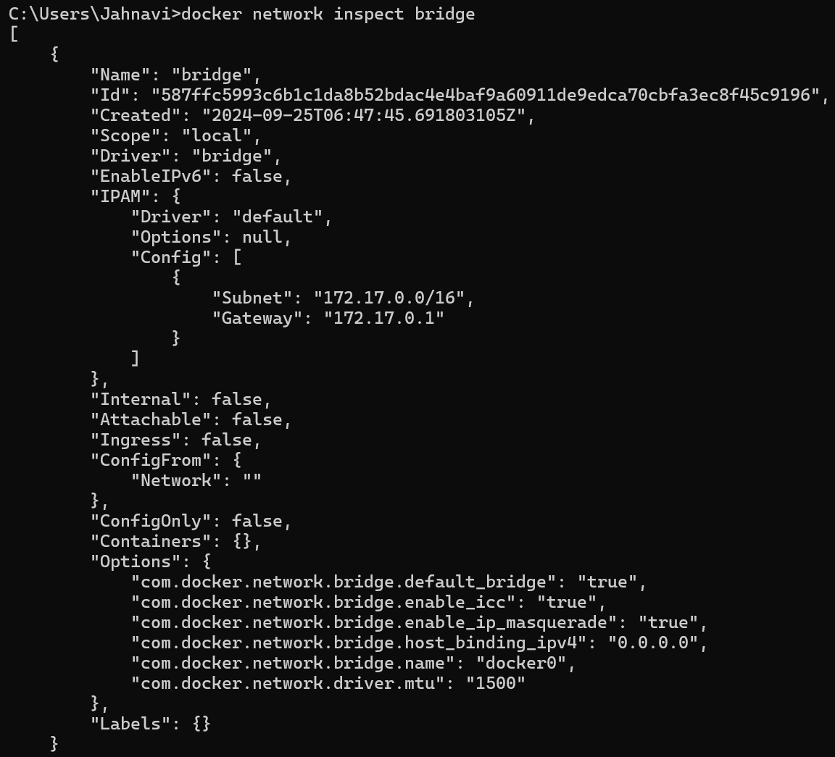

**Step 2: Create and Use a Bridge Network**

**2.1. Create a User-Defined Bridge Network**

A user-defined bridge network allows containers to communicate by name instead of IP.

docker network create my_bridge



**2.2. Run Containers on the User-Defined Network**

Start two containers on the newly created my_bridge network:



docker run -dit --name container1 --network my_bridge busybox

docker run -dit --name container2 --network my_bridge busybox

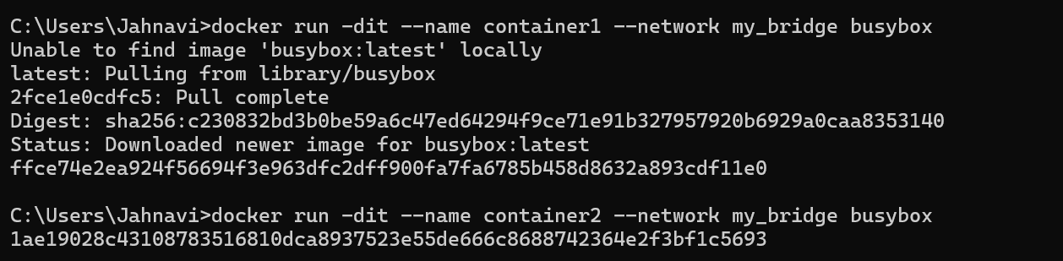

**2.3. Test Container Communication**

Execute a ping command from container1 to container2 using container names:

docker exec -it container1 ping container2

The containers should be able to communicate sinc1e they are on the same network.

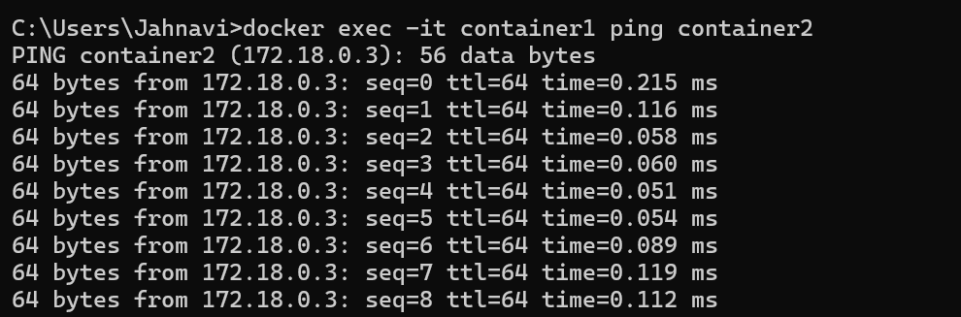

**Step 3: Disconnect and Remove Networks**

**3.1. Disconnect Containers from Networks**

To disconnect container1 from my_bridge:

docker network disconnect my_bridge container1



**4.2. Remove Networks**

To remove the user-defined network:

docker network rm my_bridge

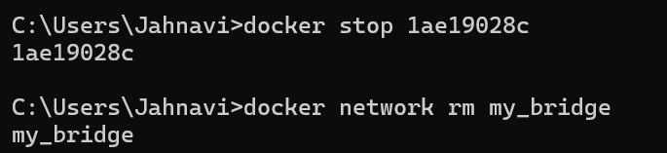

**Step 4: Clean Up**

Stop and remove all containers created during this exercise:

docker rm -f container1 container2

